Scatter Plot

Definition
# Source: AI Source: Provided by: [Data Path: Persons Table -> ID Column: 1, Name_En Column: Motasem Essam] -> From: [Chatgpt (GPT‑5 Mini)] on [12/10/2025]
A Scatter Plot is a type of data visualization that displays individual data points on a two-dimensional graph, using the x-axis for one variable and the y-axis for another variable. It is used to observe relationships or correlations between two variables.

Key Idea
# Source: AI Source: Provided by: [Data Path: Persons Table -> ID Column: 1, Name_En Column: Motasem Essam] -> From: [Chatgpt (GPT‑5 Mini)] on [12/10/2025]
Scatter plots help identify patterns, trends, clusters, or outliers in data. They are particularly useful for exploring relationships between two numerical variables.

How It Works
# Source: AI Source: Provided by: [Data Path: Persons Table -> ID Column: 1, Name_En Column: Motasem Essam] -> From: [Chatgpt (GPT‑5 Mini)] on [12/10/2025]
- Assign one variable to the x-axis and another to the y-axis.
- Plot each observation as a point on the graph.
- Analyze the distribution and alignment of the points to understand relationships.

Example
# Source: AI Source: Provided by: [Data Path: Persons Table -> ID Column: 1, Name_En Column: Motasem Essam] -> From: [Chatgpt (GPT‑5 Mini)] on [12/10/2025]
Dataset: Hours Studied vs. Exam Scores
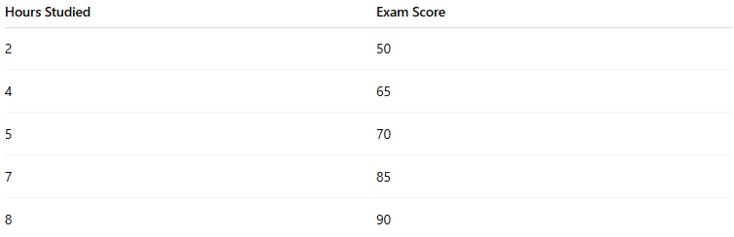
Hours Studied | Exam Score
2 | 50
4 | 65
5 | 70
7 | 85
8 | 90
- x-axis = Hours Studied
- y-axis = Exam Score
- Each point represents one student's performance
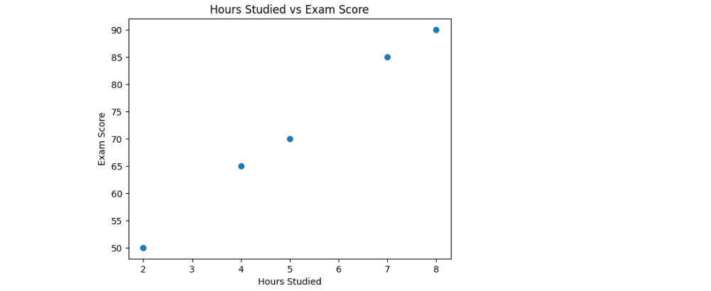
Observation: As hours studied increase, exam scores tend to increase → positive correlation.

Applications
# Source: AI Source: Provided by: [Data Path: Persons Table -> ID Column: 1, Name_En Column: Motasem Essam] -> From: [Chatgpt (GPT‑5 Mini)] on [12/10/2025]
- Identifying correlation between two numerical variables
- Detecting outliers
- Visualizing clusters or groupings
- Input for regression analysis

Advantages
# Source: AI Source: Provided by: [Data Path: Persons Table -> ID Column: 1, Name_En Column: Motasem Essam] -> From: [Chatgpt (GPT‑5 Mini)] on [12/10/2025]
- Clearly shows relationships and patterns between variables
- Easy to detect outliers and clusters
- Simple yet informative visualization

Disadvantages
# Source: AI Source: Provided by: [Data Path: Persons Table -> ID Column: 1, Name_En Column: Motasem Essam] -> From: [Chatgpt (GPT‑5 Mini)] on [12/10/2025]
- Only shows two variables at a time (unless using 3D scatter plots)
- May become cluttered with large datasets
- Does not provide causal relationships

